Business Process: Interim Service Agreement
Contact
Business Process Owner | Billing Operations – Billing Solutions
Subject Matter Expert(s) | Jhoan Funez, Katherine Martinez, Michele Gwin
Key Contact | Maya Duarte
Key Role | Customer Services Representative II
Date Created | 4/22/2026

Business Process Overview
The Interim Service Agreement (ISA) process enables SMUD to automatically place a property owner on service when a rental unit becomes vacant for more than three business days.
The process begins when a customer submits a request to apply for an ISA. Billing Solutions reviews the request, confirms ownership, and verifies that all required meters, including house meters, are correctly assigned to the property owner. Once the information is validated the ISA is created in SMUD’s customer information system (SAP ECC), enabling automatic service placement to the owner during vacancies.
Finally, Billing Solutions sends confirmation to the customer and documents the completed setup. The process concludes when the property owner is enrolled in the ISA program and automatic service restoration is enabled.

Business Process Assumptions, Prerequisites, Dependencies
(Assumptions pertaining to the business process)
People | - Assumptions:  - Completed Billing Foundations training  - Prerequisites:  - N/A  - Dependencies:  - Billing Operations permission approvals such as SAP ECC, CRM, and SharePoint access  - Contact Center submit requests, cancel, etc.
Process | - Assumptions:  - ISA Program exists  - Receive requests from our customers (New requests, Cancel, Manager Portal etc.)  - Able to confirm property ownership to ensure alignment with program requirements  - Prerequisites:  - N/A  - Dependencies:  - Report Tree:  - 2035 ISA Dunning Report  - 3500 ISA Location With No Active Contract Report (Report Tree Item)  - Report is redundant due to ZCS_INA_DISCO program for Inactive Usage Disconnects.  - Report to be deprecated.
Technology | - Assumptions:  - Manager Portal exists  - Perquisites:  - N/A  - Dependencies:  - CRM  - Excel workbook (tracking, managing program)  - Real Quest (verification of ownership)  - SAP ECC – Customer Information System  - Enrollments rely upon ZCS_ISAMOVE a custom program to process Move Orders in mass  - ISA Manager portal relies upon ZISA_MAINT customer program for managing Master ISA#  - SharePoint (folders storing application, enrollments, document repository and Excel workbook for program management)  - Smud.org (new requests and Manager portal)  - Sacramento County Assessors Records

Process Flowchart
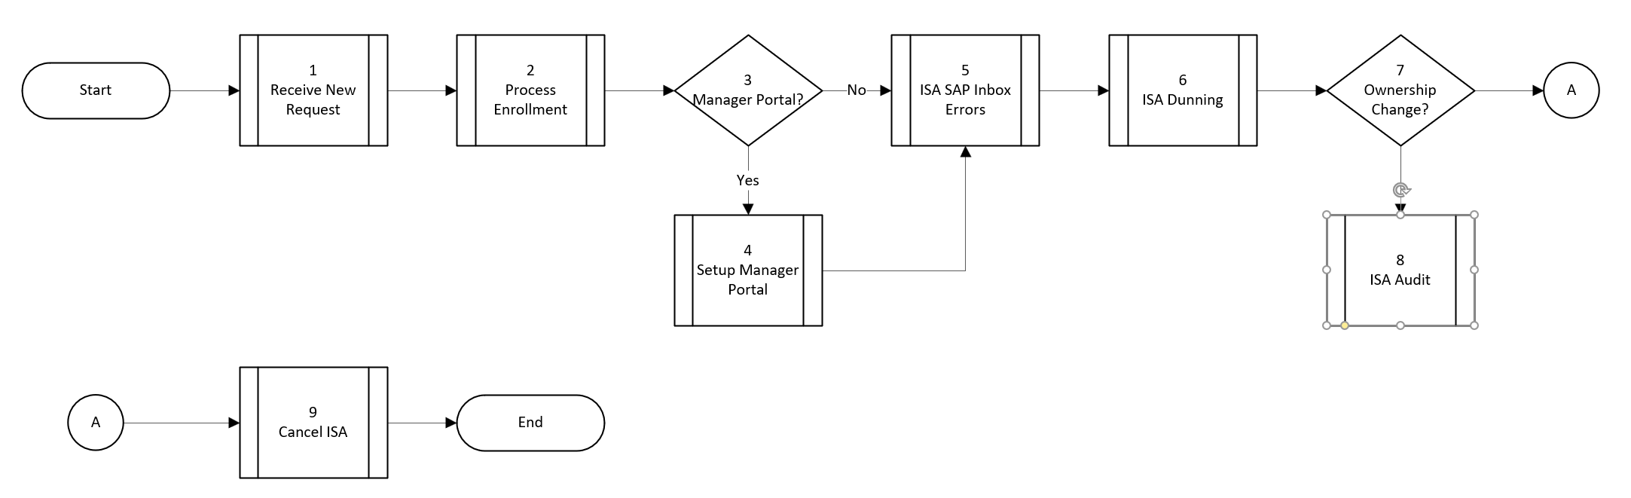

Task Description
Id | Task Description | Procedure
1 | Receive New Request | See Supporting Documents section
2 | Process Enrollment | See Supporting Documents section
3 | Manager Portal? | Confirm if customer requests Manager Portal
4 | Setup Manager Portal | See Supporting Documents section
5 | ISA Error Inbox | See Supporting Documents section
6 | ISA Dunning | See Supporting Documents section
7 | Ownership Change? | Confirm if there is an ownership change related to step 6 for unpaid balances
8 | ISA Audit | See Supporting Documents section
9 | ISA Cancel | See Supporting Documents section

Business Rules
Id | Event Name | Business Rules
 | Multiple* | See Supporting documents

Event | Legal Requirements, Rules, and Regulations  Legal documents/ procedures/ requirements to be fulfilled before/at the specified event.
Id | Event | Legal Requirements, Rules and/or Regulations
6 | ISA Dunning | - MUD Act Compliance with disconnection activities (Chapter 6 Article 5 Section: 12822.1. a) which specifies disconnection requirements for RSMM, the district shall place a written notice on the door of each residential unit at least 15 days prior to termination.

Pain Points and Improvement Opportunities

2035 ISA Dunning Report (Report Tree)

The daily process depends on Report Tree, which is being retired with S/4HANA.

Statements of Account are generated for distribution, along with past due letters.

The Statement of Account requires manual intervention prior to distribution.

Dunning activity and related statuses, as well as amounts collected or transferred, are tracked in an Excel workbook.

Balance transfers are performed manually, although this step may be eligible for automation.
- RSMM accounts are tracked with this ISA report requiring manual follow-up and maintenance

ISA Audit

Customers do not notify SMUD when ownership changes occur, which results in reactive processing and manual balance transfers or uncollectable balances.

Ownership changes are tracked manually in an Excel workbook.

ISA Cancel

Work completion is tracked in an Excel workbook.

Several manual transactions are required to complete enrollment, and this may be a candidate for workflow automation.

To cancel an ISA agreement, the customer must move out, and the move-out must be entered manually in CRM.

No mass processing function is available for move-outs.

ISA Cancel Report

Users access a CSV file from the output directory.

The required information is not available in the source system.

ISA Enrollment

Several manual transactions are required to complete enrollment, and this may be a candidate for workflow automation.

Program participants and enrollment status are tracked in an Excel workbook.

The enrollment letter process is manual and could be automated.

The letter includes customer enrollment details such as account numbers.

Enrollment contracts are stored in SharePoint.

Question: Can these be linked to a Business Partner or another SAP object?

There is a limit of 50 apartment units per Contract Account number.

Apartment unit numbers are not displayed in numerical order (for example, 1–50), so users must count selected apartments and group the correct units together when processing move-ins.

The 50-apartment limit was previously reported as a My Account visibility issue.

It is unclear whether this issue still exists.

ISA Manager Portal

The customer must already have a My Account profile in order to link to the Manager Portal.

ISA New Request

New requests are manually generated using the Word wizard from the Contact Center.

Folders are used to track work status for new and pending requests.

Enrollment and work completion are tracked in an Excel spreadsheet.

Manual letter creation is part of the process and could be automated.

ISA SAP Inbox Errors

Errors require research and manual email communication with Contact Center representatives when caused by operator errors. Ideally the system would automate this and eliminate this manual process either presenting a hard-stop blocking the condition to occur or reactively notifying users responsible upon issue detection.

Some errors are caused by system issues.

For example, if a move-in date is changed, the ISA move order does not always re-trigger as expected.

Web orders may be contributing to move-in-related issues.

Departments impacted by process change

Department | Type of Change(s) | Action Required
Billing Operations | - TBD | - TBD
Contact Center | - TBD | - TBD
Commercial Delivery | - TBD | - TBD
Field Metering | - TBD | - TBD
Revenue Assurance | - TBD | - TBD

Supporting Documentation
(Any subsequent documentation in support of this business process (i.e. business requirements, technical specs, etc.) shall be summarized in the following table.)
Document Type | Link | Notes
Blueprint | ISA Audit.xlsx
Blueprint | ISA Cancel Blueprint.docx
Blueprint | ISA Cancel Report.xlsx
Blueprint | ISA Enrollment Blueprint.docx
Blueprint | ISA Location w_No Active Contract Report.xlsx | 4/23/2026: Report being deprecated.
Blueprint | ISA Manager Portal.xlsx
Blueprint | ISA SAP Inbox Errors.xlsx
Business Procedures | 2035 ISA Dunning Report.pdf
Business Procedures | ISA Audits.pdf
Business Procedures | ISA Cancel Report.pdf
Business Procedures | ISA Cancels.pdf
Business Procedures | ISA Enrollment procedures.pdf
Business Procedures | ISA Loc with no Active Contract Report.pdf | 4/23/2026: Report being deprecated.
Business Procedures | ISA Manager Dashboard.pdf
Business Procedures | ISA New Request.pdf
Business Procedures | ISA SAP Inbox Errors.pdf
Process Map | ISA Audit Process Mapping As Is.vsd
Process Map | ISA Cancel Process Mapping As Is.vsd
Process Map | ISA Cancel Report Process Mapping As Is.vsdx
Process Map | 2035 ISA Dunning Report Process Map.vsdm
Process Map | ISA Enrollment Process Mapping As Is.vsd
Process Map | ISA Location w_No Active Contract Report Process Mapping As Is.vsdx | 4/23/2026: Report being deprecated.
Process Map | ISA Manager Portal Process Mapping As Is.vsd
Process Map | ISA SAP Inbox Errors Process Mapping As Is.vsdx
Process Map | Interim Service Agreement Process Mapping As Is.vsdx

Business Blueprint Amendments

Any subsequent changes to this business process blueprint after the official document approval shall be summarized in the following table. This document must be reprinted and signed by the authorized representatives.
Version | Author | Description of Change | Approval (Name) | Date
1.0 | Joshua Dunn | Initial Draft | Maya Duarte | 4/23/2026

